SQL Analysis Explained
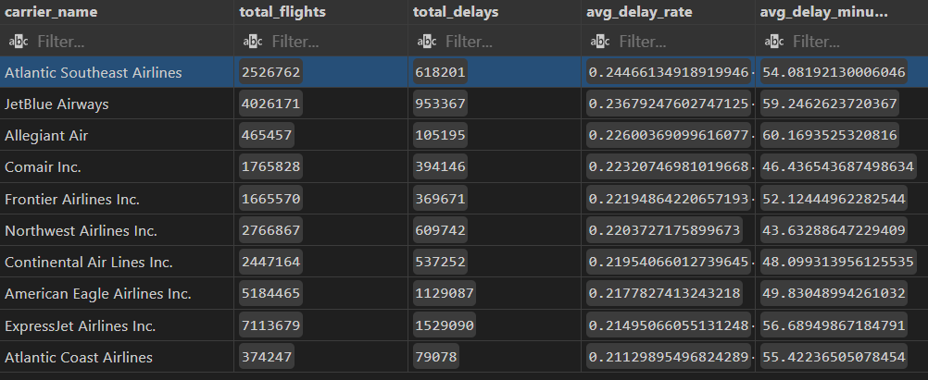
Top 10 Delay-Prone Airlines Insights
- Frequency of Delays (avg_delay_rate):
  - All 10 airlines have delay rates above ~21%, meaning 1 in 5 flights is delayed.
  - Atlantic Southeast Airlines leads with ~24.5% of flights delayed.
- Severity of Delays (avg_delay_minutes):
  - Average delay ranges from ~44 minutes (Northwest Airlines) to ~60 minutes (Allegiant Air).
  - Airlines like Allegiant Air and JetBlue Airways not only have high delay frequency but also longer delays, making their operations less reliable.
- Patterns to Note:
  - Some airlines (e.g., Northwest Airlines Inc., Comair Inc.) have high delay rates but shorter average delays, suggesting frequent but manageable delays.
  - Others (e.g., Allegiant Air, JetBlue Airways) have both high frequency and long delays, which could impact customer satisfaction and scheduling.
- Operational Insight:
  - Airlines with high delay rate + high delay duration may need improved scheduling, turnaround efficiency, or better route management.
  - Airlines with moderate delays but shorter durations are likely recovering faster, even if delays are frequent.
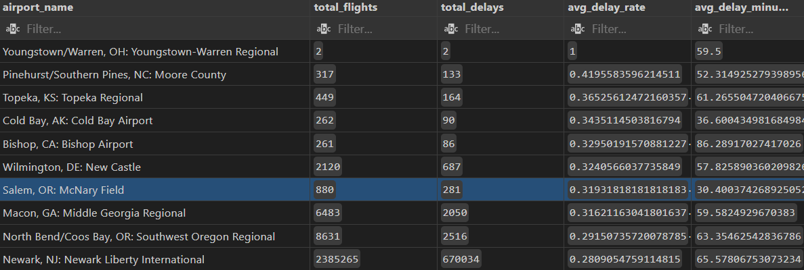
Insights from Top 10 Airports by Delay Rate
- High Delay Rates:
  - All top 10 airports have delay rates above ~28%, meaning more than 1 in 4 flights is delayed.
  - The highest delay rates are seen at small airports with very few flights, e.g., Youngstown-Warren, OH (2 flights, both delayed → 100%).
- Average Delay Duration Varies:
  - Some airports have long average delays (e.g., Bishop, CA → 86 min; North Bend/Coos Bay, OR → 63 min).
  - Others have shorter delays despite high delay rates (e.g., Salem, OR → 30 min; Cold Bay, AK → 36 min).
- Traffic Volume Matters:
  - Large airports like Newark, NJ (~2.3 million flights, 28% delayed, ~66 min avg delay) have high operational impact, even if their delay rate is lower than smaller airports.
  - Small airports can appear in top 10 due to high percentage delays, but the impact is limited because flight volume is low.
- Key Takeaway:
  - Top 10 airports with the highest delay rates include both small regional airports and major hubs.
  - For operational or planning decisions, prioritize high-traffic airports where delays affect more passengers.
  - Use both delay rate and average delay duration to understand both frequency and severity of delays.
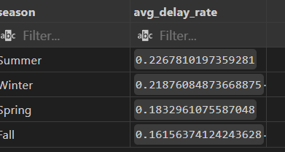
Insights from Average Delay Rate by Season
- Highest Delay Rates:
  - Summer → ~22.7% of flights delayed (highest)
  - Winter → ~21.9% delayed (second highest)
- Lowest Delay Rates:
  - Fall → ~16.2% delayed (lowest)
  - Spring → ~18.3% delayed
- Patterns & Possible Causes:
  - Summer delays may be driven by high traffic volume and congestion during peak travel months.
  - Winter delays are likely influenced by weather-related issues (snow, ice, storms).
  - Fall and Spring generally see fewer delays, likely due to moderate weather and lower travel volume.
- Key Takeaway:
  - Airlines and airports should plan for higher delay risk in Summer and Winter, both for resource allocation (staffing, gates) and passenger communication.
  - Fall and Spring are relatively more reliable for flight schedules.

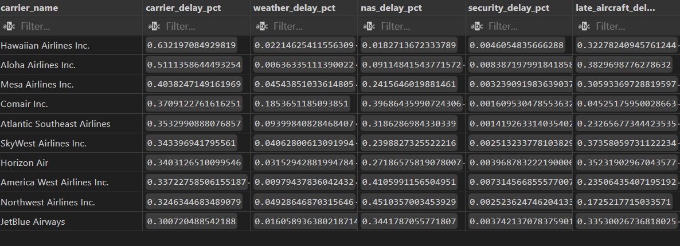
Insights from Delay Causes by Airline
- Carrier-Related Delays (carrier_delay_pct)
  - Highest for Hawaiian Airlines Inc. (~63%) and Aloha Airlines Inc. (~51%)
  - Indicates that operational issues within the airline itself (crew, scheduling, maintenance) are the dominant cause of delays for these carriers.
- Weather-Related Delays (weather_delay_pct)
  - Generally low across all airlines (most under 10%)
  - Example: Comair Inc. (~18.5%) and Atlantic Southeast Airlines (~9.4%) are exceptions
  - Insight: Weather plays a role for certain airlines, but is not the main cause for most carriers.
- NAS / Air Traffic System Delays (nas_delay_pct)
  - High for:
    - Northwest Airlines Inc. (~45%)
    - America West Airlines Inc. (~41%)
    - Comair Inc. (~39.7%)
  - Indicates air traffic congestion or airspace issues are major contributors for these carriers.
- Security Delays (security_delay_pct)
  - Very low for all airlines (<1%)
  - Suggests security-related delays are minimal compared to other causes.
- Late Aircraft Delays (late_aircraft_delay_pct)
  - High for:
    - SkyWest Airlines Inc. (~37%)
    - Horizon Air (~35%)
    - JetBlue Airways (~33.5%)
  - These delays occur when an aircraft arrives late from a previous flight, highlighting network or scheduling dependencies

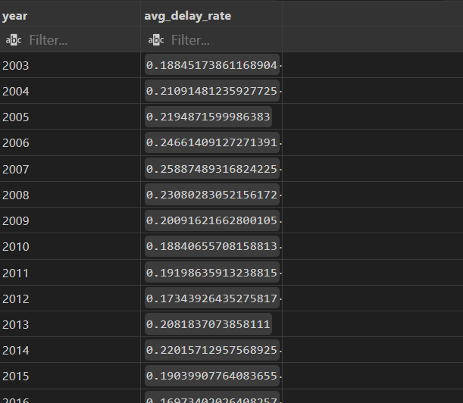

Insights from Annual Delay Trends (2003–2022)
- Overall Trend:
  - Delay rates fluctuate between ~17% and ~26% for most years, with the exception of 2020, which dropped sharply to ~9.6%.
  - This suggests that pre-COVID, delays were consistently significant, often above 20%.
- Peak Delay Years:
  - 2006 (~24.7%) and 2007 (~25.9%) had the highest average delay rates.
  - These peaks could be due to air traffic congestion, operational inefficiencies, or extreme weather events during those years.
- Lowest Delay Years:
  - 2016 (~17%) and 2012 (~17.3%) show lower-than-average delays, possibly reflecting improved operational efficiency or better scheduling.
  - 2020 (~9.6%) is an outlier due to COVID-19 reducing flight volume drastically, which significantly reduced delays.
- Recent Years (2021–2022):
  - Delay rates rise again after 2020:
    - 2021 → ~17%
    - 2022 → ~21%
  - Indicates resumption of regular flight volumes and the return of typical delay patterns post-pandemic.
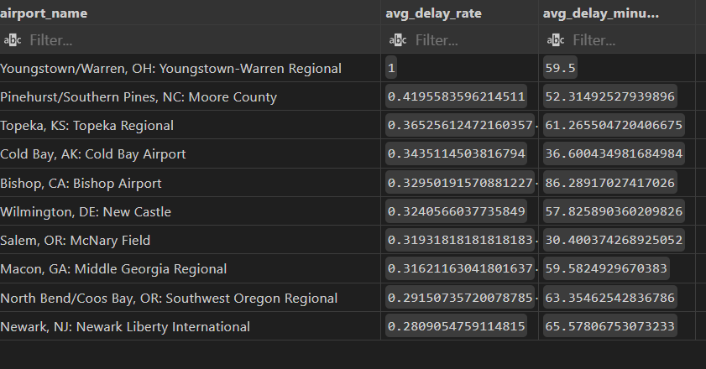
Insights from Top 10 Airports by Average Delay Rate
- Delay Frequency (avg_delay_rate):
  - The highest delay rate is Youngstown-Warren, OH → 100% (but only 2 flights, so statistically insignificant).
  - Other high-delay airports:
    - Pinehurst/Southern Pines, NC → ~42%
    - Topeka, KS → ~36%
    - Cold Bay, AK → ~34%
- Average Delay Duration (avg_delay_minutes):
  - Longest delays:
    - Bishop, CA → ~86 min
    - North Bend/Coos Bay, OR → ~63 min
    - Topeka, KS → ~61 min
  - Shortest delays:
    - Salem, OR → ~30 min
    - Cold Bay, AK → ~36 min
- Traffic Volume Consideration:
  - Some airports with very few flights appear at the top due to high percentage delays (e.g., Youngstown-Warren, Pinehurst).
  - Large airports in the top 10, like Newark, NJ, have moderate delay rates but high impact because of large flight volumes (~2.3 million flights).
- Key Takeaways:
  - Both delay rate and average delay minutes matter for understanding operational impact.
  - Small airports can skew top rankings; focus on high-traffic airports for meaningful operational insights.
  - Airports like Newark, NJ and North Bend/Coos Bay, OR are critical for passenger experience due to both frequency and severity of delays.

Final Airline Delay Analysis Summary
1. Airline-Level Insights
- Most Delay-Prone Airlines (Top 10 by Average Delay Rate):
  - Atlantic Southeast Airlines, JetBlue Airways, Allegiant Air → delay rates ~22–25%.
  - Average delay duration varies from ~43 min (Northwest Airlines) to ~60 min (Allegiant Air, JetBlue).
- Delay Cause Patterns:
  - Carrier-related delays dominate for Hawaiian Airlines (~63%) and Aloha Airlines (~51%).
  - NAS / air traffic system delays are high for Northwest Airlines (~45%) and America West (~41%).
  - Late aircraft delays are significant for SkyWest (~37%) and Horizon Air (~35%).
  - Weather delays and security delays are relatively minor for most carriers (<10%).
→ Insight: Airlines have distinct dominant delay causes, so operational improvements must be carrier-specific.

2. Airport-Level Insights
- Top 10 Airports by Average Delay Rate:
  - Highest delay rates are often small airports (e.g., Youngstown-Warren OH → 100%, Pinehurst NC → 42%).
  - Major hubs like Newark, NJ (~28% delay, 65 min avg) have moderate delay rates but large impact due to high traffic.
- Delay Duration vs Frequency:
  - Airports like Bishop, CA and North Bend/Coos Bay, OR have long delays (~60–86 min) even with lower frequency.
  - Smaller airports with extreme percentages (e.g., Youngstown-Warren) may not be operationally significant.
→ Insight: For operational planning, focus on high-traffic airports with both high delay rate and long delay duration.

3. Seasonal Patterns
- Summer → highest average delay rate (~22.7%), likely due to peak travel and congestion.
- Winter → second highest (~21.9%), mostly from weather-related delays.
- Spring and Fall → lower delay rates (~16–18%).
→ Insight: Airlines and airports should anticipate higher delays in Summer and Winter for resource allocation and passenger communications.

4. Yearly Trends (2003–2022)
- Peak delay years: 2006 (~24.7%) and 2007 (~25.9%)
- Lowest delay years: 2016 (~17%) and 2012 (~17.3%)
- COVID-19 anomaly: 2020 (~9.6%) due to drastically reduced flight volume
- Post-pandemic resumption: 2021 (~17%) and 2022 (~21%)
→ Insight: Flight delays fluctuate over time due to traffic, operational efficiency, and external factors. 2020 is an outlier.

5. Key Takeaways Across Analyses
- High-Impact Airports & Airlines:
  - Focus on large hubs (e.g., Newark, NJ) and high-traffic airlines for meaningful operational improvements.
- Delay Causes Are Airline-Specific:
  - Carrier-related, NAS, and late aircraft delays dominate depending on airline.
- Seasonal Planning Matters:
  - Summer and Winter require proactive scheduling, staffing, and communication to mitigate delays.
- Operational Improvements:
  - Airlines with high carrier delays → improve internal operations.
  - Airlines with high NAS or late aircraft delays → optimize scheduling and airspace coordination.

